Single Wire Serial
User Guide
AT21CS01 · DP1260-100695 Mezzanine Board
Single-Wire Communication Protocol

1. Overview
Single Wire Serial (also referred to as One-Wire) is a communication protocol based on an open-drain / tristate bus topology, similar to I²C. All communication between the host and client occurs over a single, shared data line.
The host and client each take turns pulling the data line low for defined durations. A shorter low pulse represents a logical 1(NACK), while a longer low pulse represents a logical 0(ACK). When neither party is actively driving the line, an external pull-up resistor holds the line high.
Power delivery is achieved via parasitic power, using capacitors to source current during communication cycles.

NOTE This protocol is fully asynchronous. Correct operation depends on precise timing. Deviation from specified timing parameters may result in communication errors or data corruption.

1.1 Target Device
This library is designed to communicate with the AT21CS01 EEPROM, as fitted on the DP1260-100695 Mezzanine Board.

1.2 Supported Operations
The following operations are implemented:

Operation | Description
Device Reset | Resets the device. No address configuration required.
Manufacturer ID Read | Reads the 24-bit Manufacturer ID from the device.
Serial Number Read | Reads the 64-bit unique serial number from address 0x0000.
Current Address Read | Reads from the most recently accessed memory address.
Random Address Read | Reads a single byte from a user-specified memory address.
Sequential Read | Reads multiple sequential bytes starting from a specified address.
Byte Write to EEPROM | Writes a single 8-bit byte to a user-specified EEPROM address.
Page Write to EEPROM | Writes a full page of data to EEPROM. (8 Bytes)
Byte Write to Security Reg. | Writes a single byte to the security register.
Page Write to Security Reg. | Writes a full page to the security register. (8 Bytes)
Lock Security Register | Permanently locks the security register against further writes.

2. Device Reset – Reset And Discovery Response
A Reset and Discovery Response sequence is used by the host to reset the device as well as to perform a general bus call to determine if any devices are present on the bus. It is also used to ensure the AT21xxxx has sufficient power to begin reliable operation.

WARNING Allegedly due to the parasitic power feature , if you go into a write operation first thing , your data will very likely corrupt, The device need adequate power to run reliably , to ensure this , you may run the reset twice , or any read operation before performing writes. This needs further testing.

No address configuration is required; the operation can be invoked directly.
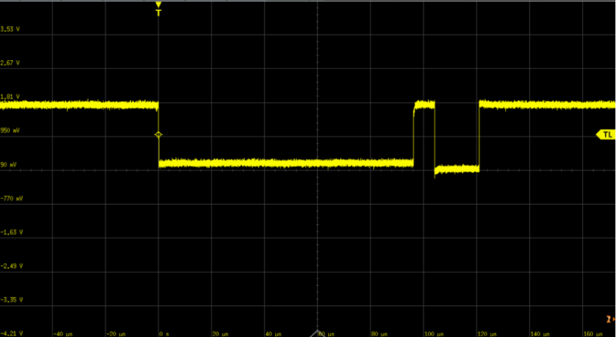

Configuration
- No configuration required. Run the command as-is.

Communication Sequence
- Host drives the SI/O line low for the reset duration (tRESET).
- Host releases the line.
- Client issues a presence pulse to confirm successful reset.

NOTE This function is also useful to identify whether an AT21xxx is in working condition.

3. Manufacturer ID Read
Reads the 24-bit Manufacturer Identifier from the device. No user configuration is required.
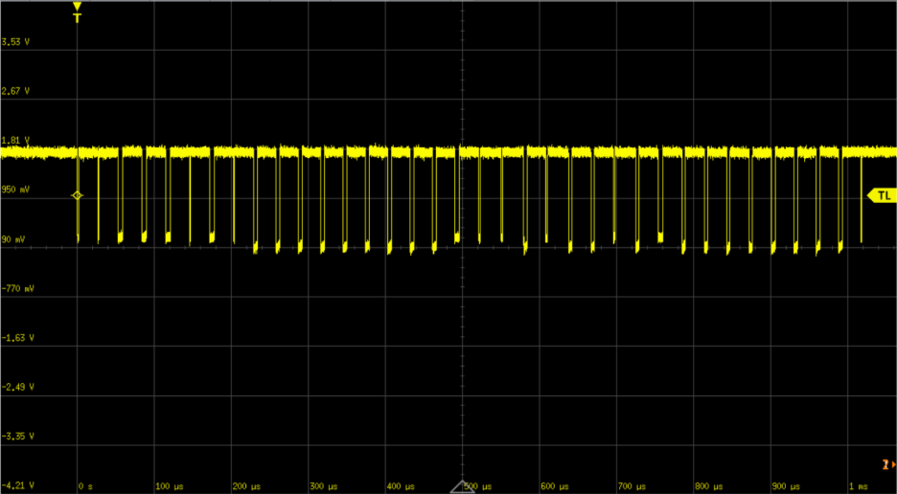
Configuration
- No configuration required. Run the command as-is.

Communication Sequence
- Host sends the Device Address with Opcode 1100b.
- Device returns 3 bytes containing the Manufacturer ID.

NOTE The Manufacturer Identifier is encoded in the 12 Most Significant bits of the three bytes. The value assigned to Microchip is 0x00Dh, so the first byte returned will be 0x00 and the upper nibble of the second byte will be 0xD.
NOTE The 12 Least Significant bits encode the device density (bits D11–D3) and the device revision (bits D2–D0).

Example Output
SWS Read Test Starting
In the loop
Read completed
Manufacturer ID: 00 D2 00

4. Current Address Read
Reads a single byte from the address pointer last used during a read operation. No address parameter is required.
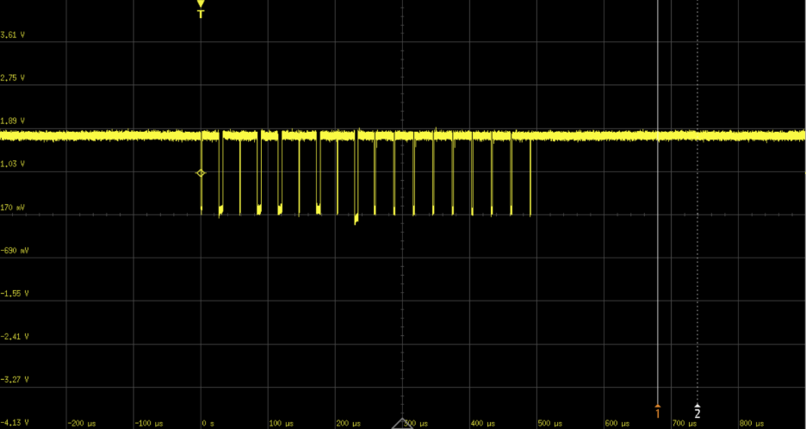
Configuration
- No configuration required. Run the command as-is.

Communication Sequence
- Host sends the Device Address with the R/W bit set to 1 (Read).
- Device returns a single data byte.

Example Output
SWS Read Test Starting
In the loop
Read completed
Current Address Read: 0xFF

5. Sequential Read
in the source code before running. The sequential read is identical to the serial number read Reads multiple consecutive bytes starting from a specified memory address. Set the starting address with the only difference being what memory address is set.

Configuration
- Set the starting memory address in the C source code in the glossary..
- Do not modify the Device Address.

Communication Sequence
- Host sends the Device Address + Opcode with the R/W bit set to 0 (Write).
- Host sends the starting Memory Address byte.
- Host re-sends the Device Address + Opcode with the R/W bit set to 1 (Read).
- Device returns the requested number of sequential bytes.
Example Output
SWS Read Test Starting
In the loop
Read completed
Serial Number: A0 15 C9 89 02 00 00 1C

6. Random Address Read
Reads a single byte from a user-specified memory address. The target address must be set in the C code before running the command.
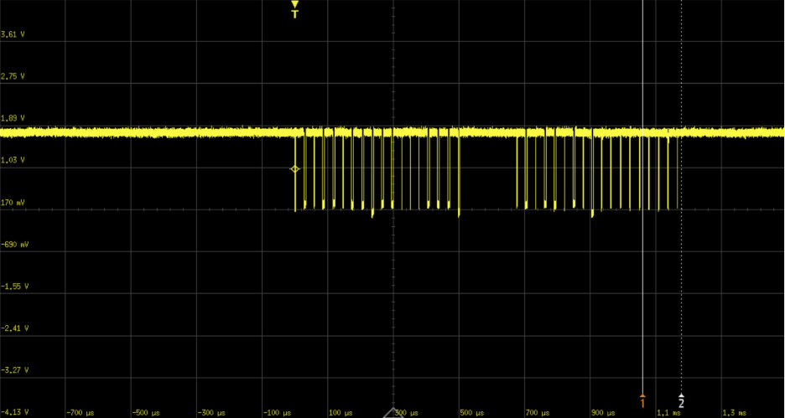
Configuration
- Set the desired memory address in the C code.
- Do not modify the Device Address.

Communication Sequence
- Host sends the Device Address with the R/W bit set to 0 (Write).
- Host sends the target Memory Address byte.
- Host re-sends the Device Address with the R/W bit set to 1 (Read).
- Device returns a single data byte.

Example Output
SWS Read Test Starting
In the loop
Read completed
Random Address Read [0x38]: 0xFF

7. Serial Number Read
Reads the full 64-bit unique serial number from the device. The memory address is fixed to the value specified in the datasheet (0x0000); no code changes are required.
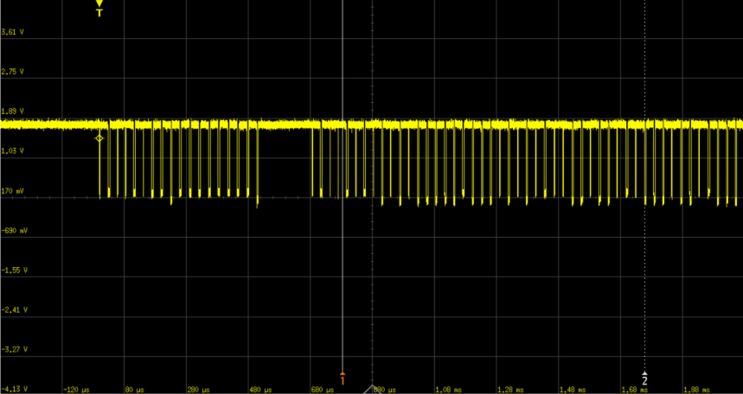
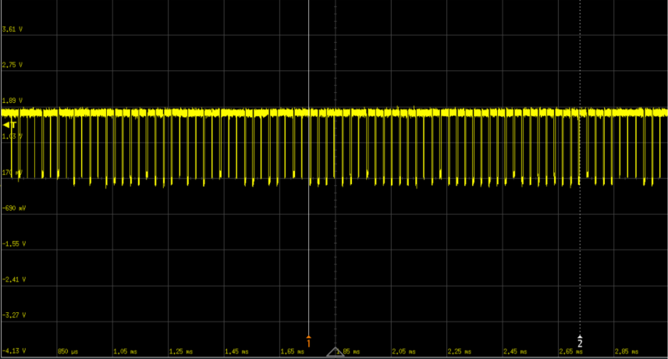
Configuration
- No configuration required. Run the command as-is.

Communication Sequence
- Host sends the Device Address + Opcode with the R/W bit set to 0 (Write).
- Host sends Memory Address (0x0000 if serial number read).
- Host re-sends the Device Address + Opcode with the R/W bit set to 1 (Read).
- Device returns 8 bytes.

WARNING Do not modify the memory address used by this function. The address is pre-set to the correct location as defined by the AT21CS01 datasheet.

NOTE Byte 0 contains the product identifier (0xA0).
NOTE Bytes 1–6 contain the 48-bit unique device identifier.
NOTE Byte 7 is a CRC-8 checksum (Maxim/Dallas algorithm) over the preceding 7 bytes.

Example Output

SWS Read Test Starting
In the loop
Read completed
Serial Number: A0 15 C9 89 02 00 00 1C

8. Byte Write to EEPROM / Security Register
Writes a single 8-bit byte to a specified EEPROM or Security Register address. Both the target address and the data byte must be configured before running.
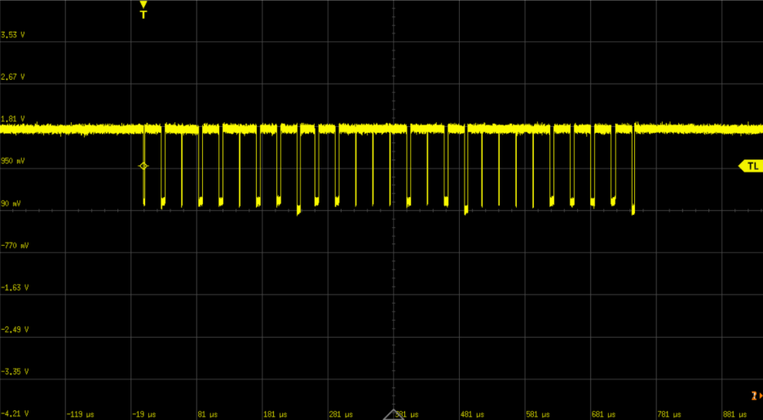
Configuration
- Set the target memory address in the C source code in the glossary.
- Set the data byte to be written in the C source code in the glossary.
- Do not modify the Device Address.

Communication Sequence
- Host sends the Device Address + Opcode.
- Host sends the target Memory Address byte.
- Host sends the data byte to be written.

WARNING Interrupting the internal write cycle by driving the SI/O line low may corrupt the byte being written. Other memory locations will not be affected. If the host must abort a write, the SI/O line must be driven low for tDSCHG as described in the datasheet section “Interrupting the Device During an Active Operation.” This applies for all write operations.

NOTE The AT21CS01 requires a 7-bit memory word address to select the target byte. A full write cycle completes before the next operation can begin.

9. Page Write to EEPROM / Security Register
Writes a full page of data (up to 8 bytes) to EEPROM in a single operation. Both the starting address and the data buffer must be configured in the source code before running.

Configuration
- Set the starting memory address in the source code.
- Populate the data buffer with the bytes to be written.
- Do not modify the Device Address.

Communication Sequence
- Host sends the Device Address + Opcode.
- Host sends the starting Memory Address byte.
- Host sends each data byte sequentially.
- Device internally commits the full page write.

WARNING Interrupting the internal write cycle by driving the SI/O line low may corrupt the page being written. If the host must abort the operation, the SI/O line must be driven low for tDSCHG as described in the datasheet section “Interrupting the Device During an Active Operation.”

NOTE A page write is limited to a single page boundary. Writing across a page boundary will cause the address counter to wrap within the same page rather than advancing to the next.

10. Lock Security Register
Permanently locks the security register, preventing any further write operations to it. This action is irreversible — once locked, the contents of the security register cannot be modified.

Configuration
- No configuration required. Run the command as-is.

Communication Sequence
- Host sends the Device Address + Lock Opcode.
- Device permanently sets the lock bit in the security register.

WARNING This operation is permanent and cannot be undone. Confirm all intended data has been written to the security register before executing this command.
NOTE The AT21CS01 requires a 7-bit memory word address to select the target byte. A full write cycle completes before the next operation can begin.

11. General Notes
Busy / Write-Cycle Polling
A busy-polling function has not been implemented in this library. Due to the design of the host-side interface, this is not required under normal operating conditions. If the start function is called in a loop, ensure the inter-call delay (usleep) is not set to an unreasonably small value.
NOTE A minimum inter-call delay of 500 ms is suggested for reliable operation when looping the start function. In typical use cases, a 1-second delay is sufficient and well tested. The latter is highly recommended.

